Nursery Home Learning Suggestions
Week beginning 25/5/20
Monday
Kay’s Literacy activity:
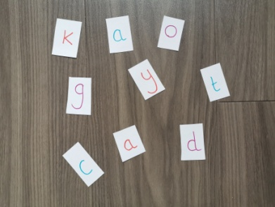
Fun Phonics Game: Ask an adult to write some familiar letters or words onto small pieces of paper and scatter them onto the table or floor face up. Get your adult to say the word or phonic sound for these letters. How fast can you find and pick up the letter? If you have a straw you can try to sook up the words or letters too.
Katie’s Numeracy activity
Number Spotting: Make a pair of binoculars using toilet roll tubes or anything else you can think of. When you’re outside in your garden, on a walk or even just looking out the window count how many…… birds you see, cars you see, people you see.

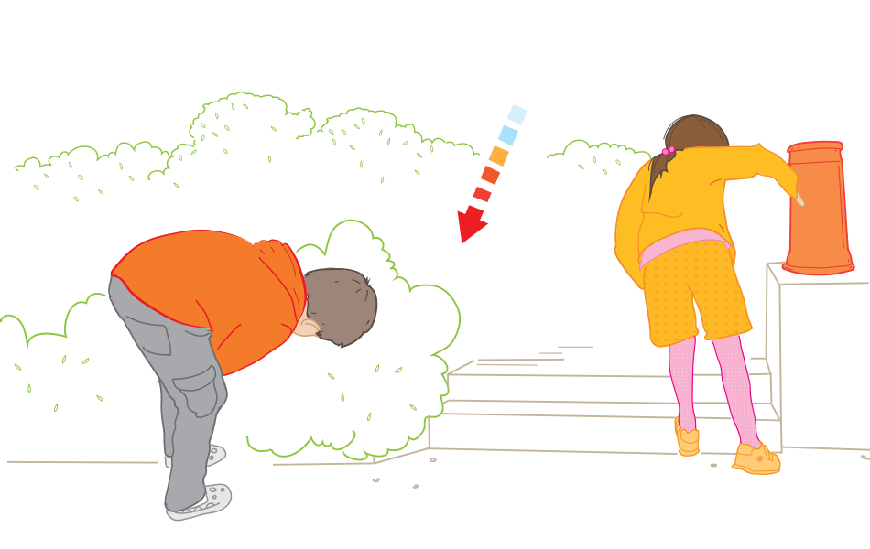
Carol’s Health and Wellbeing activity:
The Hot and Cold Game: Choose an item to hide. The other people close their eyes. NO PEEKING!! When they start looking give them clues, “hot” if they are close, “cold” if they are far away. When they find it swap over and play again!
Tuesday
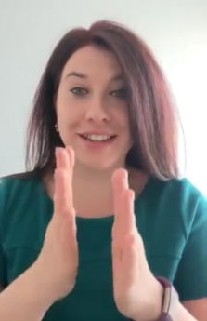
Susan’s Literacy activity:
Let’s try signs: Have a go at signing some of the daily signs from Kayleigh or signing along to any of the songs/ stories on the YouTube channel that have been done with signs, five little ducks, dingle dangle scare crow, dear zoo, animal fayre & Call it Alba are a few to get you started. Can you teach an adult any of the signs we’ve learnt at nursery?
Fiona L’s Numeracy activity:
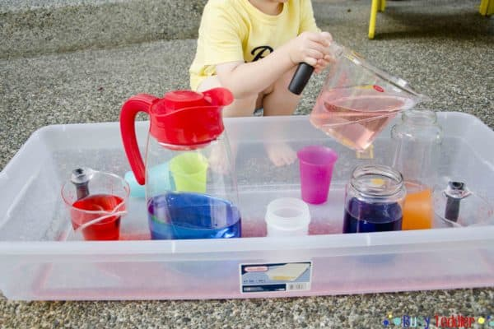
Measuring: Find some different sized items around your house that you can put water in such as empty bottles, bowls, jugs, spoons or anything else you can think of. Experiment with water to discover measurements. An adult could ask you questions like, “How many smaller bottles does it take to fill one bigger bottle?”

Leah’s Health and Wellbeing activity:
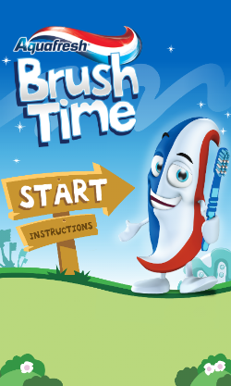
Are you ready to Brush?: Ask an adult to download the aquafresh brush time app on to any mobile device or listen to the song using the link below. This is the toothbrushing song we listen to while brushing our teeth at nursery. Can you show your adult how you brush your teeth for two minutes following the song?
https://www.youtube.com/watch?v=8FTRwjqXCsc

Wednesday
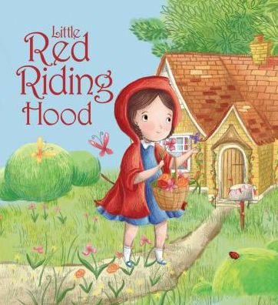
Fiona M’s Literacy activity:
Story Guessing Game: Look at the books you have at home. Think of a book in your head and give your family clues to the story. “There is a wolf.” Keep giving new clues until they guess the story. “The girl visits her Granny.” The person who guesses first swaps places with you and it becomes their turn.

Diane’s Numeracy activity:
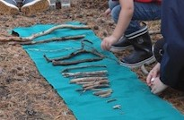
Comparing sticks: Collect some sticks while out on a walk or from your garden. Lay the sticks out. Can you talk about their size and width? Which one is tallest? Which one is thickest? Can you order the sticks shortest to longest or thickest to thinnest?
Brenda’s Health and Wellbeing activity:
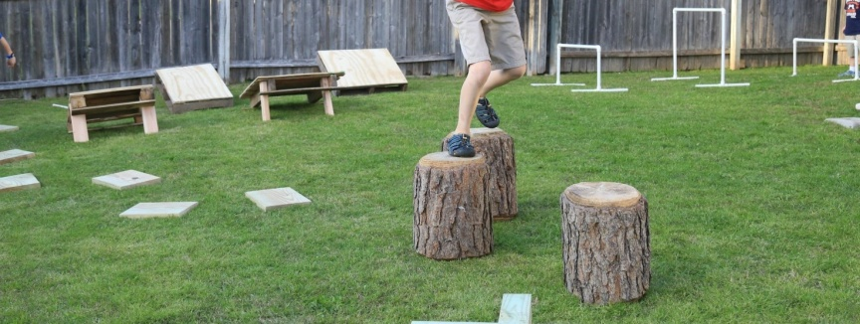
Floor is Lava: Using loose parts around your house or garden can you build a little course to navigate round the room/ garden without touching the ground? Careful not to step in the lava it’s hot!
Thursday
Jill’s Literacy activity:
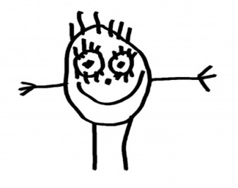
Let’s talk about nursery: Talk to an adult about one of your friends or your Key Group Teacher. Can you draw a picture of this person? Ask an adult to write their name at the top and some words about what you remember/ miss about them. You could even have a go at writing some words yourself if you like.
Jill
Stacey’s Numeracy activity:
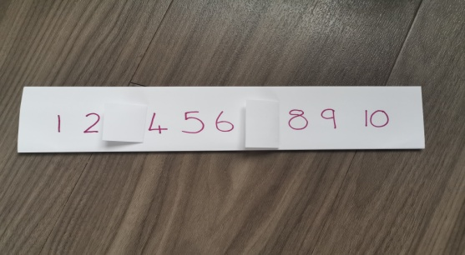
Missing Number: Ask an adult to write a number line 0-10 on a piece of paper or you could use your handprint number line from a couple of weeks ago if you made one. Using a smaller piece of paper cover one of the numbers. Can you work out which number is missing?

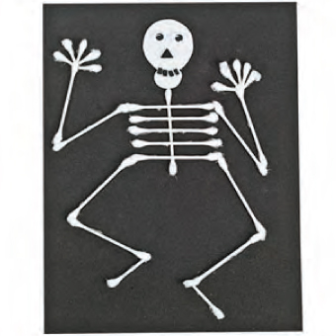
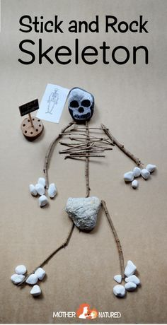
Emma’s Health and Wellbeing activity:
Dancing Bones: One of our favourite songs to sing along to in nursery is The Skeleton Dance. https://www.youtube.com/watch?v=qeSSmNRBlgY Sing and dance along. Try to get your adults to join in too. Thinking about the human body can you make a transient art skeleton using sticks, cotton buds or anything else you can think of?

